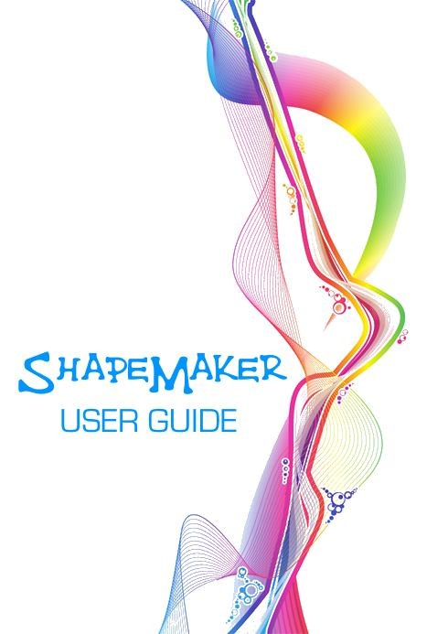

Sha peMa k er User Guide

A paint.net plugin by
The Dwarf Horde
Rob Tauler (TechnoRobbo) - Code Lead, Design
John Robbins (Red Ochre) - Graphics Lead, Design
Scott Stringer (Ego Eram Reputo) - Documentation Lead, Design
Last revision 25 April 2015

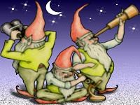

Index
Foreword...............................................................................................................................6
Why did we write this plugin?...............................................................................................6
Definitions used in this guide................................................................................................7
ShapeMaker User Interface (UI) ...........................................................................................8
File Menu...............................................................................................................................9
Load/Save PDN Shape............................................................................................................9
Paste Path Stream.................................................................................................................9
Copy Path Stream................................................................................................................ 10
Export PathGeometry........................................................................................................... 10
Edit Menu ............................................................................................................................10
Remove Line (Delete key)..................................................................................................... 11
Clone Line........................................................................................................................... 11
Loop Line (Ctrl + 1)............................................................................................................. 11
Flip Horizontal..................................................................................................................... 11
Flip Vertical......................................................................................................................... 12
Clear All ............................................................................................................................. 14
Help Menu ...........................................................................................................................15
User's Manual...................................................................................................................... 15
Keyboard Shortcuts ............................................................................................................. 15
About................................................................................................................................. 15
Tool Bar...............................................................................................................................16
Undo.................................................................................................................................. 16
Snap to Grid ....................................................................................................................... 17
Linked................................................................................................................................ 17
Closed................................................................................................................................ 17 Drawing Grid.......................................................................................................................19
Path List, Editing Tools & Options........................................................................................21
Line Mode........................................................................................................................... 21
Path Mode .......................................................................................................................... 21
Path List............................................................................................................................. 23
Up/Down Arrows ................................................................................................................. 23
Apply Edit........................................................................................................................... 23
Deselect............................................................................................................................. 24
Nub Location....................................................................................................................... 24
Rotate Knob........................................................................................................................ 24
Output Scale....................................................................................................................... 24
Shape Name....................................................................................................................... 25
Image Tracing Opacity ......................................................................................................... 25
Fit Background.................................................................................................................... 26
2x View.............................................................................................................................. 26
Draw on Canvas.................................................................................................................. 26
Drawing Types.....................................................................................................................27
The Primitive Types.............................................................................................................28
Straight Line....................................................................................................................... 28
Cubic Bézier........................................................................................................................ 28
Quadratic Bézier.................................................................................................................. 29
Ellipse................................................................................................................................ 30
The Smooth Types...............................................................................................................33
Smooth Cubic Bézier............................................................................................................ 33
Smooth Quadratic Bézier...................................................................................................... 34
The Compound Types ..........................................................................................................36 Rectangle ........................................................................................................................... 36 Circle................................................................................................................................. 36
Creating Points....................................................................................................................38
Creating Primitives, Smooth Types or Compound Types......................................................38
Moving Points and Objects..................................................................................................39
Quick Start Guide ................................................................................................................40
Quick Reference - Primitive Types.......................................................................................42
Quick Reference - Smooth Types.........................................................................................43
Quick Reference - Compound Types ....................................................................................43
Quick Reference - Mouse & Keyboard Shortcuts..................................................................44

Foreword
The ShapeMaker plugin is a tool which facilitates the creation of SVG (Scalable Vector Graphics) Shapes, Lines and Curves.
The tool itself uses a WYSIWYG interface where Lines, Curves and entire Paths can be created and manipulated using just the mouse. Knowledge of the complex SVG structure is not required. ShapeMaker will create all that complex stuff for you and generate the Shape, code, or a complete reusable file.

Why did we write this plugin?
We wanted to create an easy-to-use click-and-drag interface which could create custom Shapes that paint.net itself could reuse via the new Shapes tool. That's right. Paint.net 4.0.6+ allows the user to add their own Shapes to the Shapes tool set. Not only can ShapeMaker Shapes be reused, the valid SVG generated can be pasted into HTML documents for modern browsers to render.

We hope you like ShapeMaker!

~ TechnoRobbo
~ Ego Eram Reputo
~ Red Ochre

Definitions used in this guide
Circle - a compound type consisting of two semi-circular Ellipses.
Compound Types - One of two shapes (Rectangle and Circle) which are composed of individual elements to create the Shape. A Rectangle is composed of four Straight Lines and a Circle is two semi-circular Ellipses. These two compound types are included to ease drawing these common shapes. A kind of macro or shortcut.
Control nub - a little graphic representing a dragable control point.
Curve - any one of a number of Curve types which extend between two points (Start and End). In ShapeMaker Curves have one or more control nubs which can be used to alter them.
Drawing Grid - the square space where Lines, Curves and Paths are created and edited.
Ellipse - a special type of Curve. Ellipses create their own individual Path and cannot be joined in a series like the other types.
End point - the place where a Line or Curve terminates.
Line - a straight Line between two points: Start point and End point.
Line Mode - refers to a selected Line being edited or a new Line being drawn.
Mid point - any point occurring in a Path that is not a Start or End point.
Path - a series of continuous connected Lines or Curves of the same type. Ellipses and Circles cannot be joined in series to create a Path.
Path List - the contents of the Path pane. Paths created are listed here - just like paint.net's Layers window.
Path Mode - refers simultaneously to all the Paths in the Path List. This happens when no Lines, Curves or Paths are selected and the ShapeMaker editing buffer is empty.
Primitive Types - one of the Line/Curve types: Straight Line, Cubic Bézier, Quadratic Bézier or Ellipse.
Rectangle - a compound type consisting of four parallel Straight Lines.
Shape - the object created from all the Paths in the Path List.
Smooth Types - a subset of Curves which interact with neighboring Curves in the same Path to make the overall Curve continuously smooth. There are two Smooth types: Smooth Cubic Bézier and Smooth Quadratic Bézier.
Start point - the place where a Line or Curve begins.

ShapeMaker User Interface (UI)
The ShapeMaker UI can be divided into four main areas; Menus - File, Edit and Help.
Tool Bar - with icons for various Lines, Curves and options.
Drawing Grid - where Shapes are created.
Path List, Editing Tools & Options.

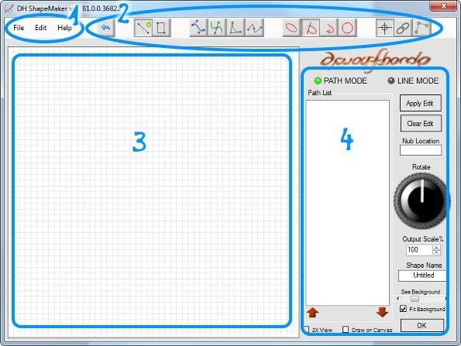

File Menu
This menu contains basic file handling options. The menu can be opened by clicking on it or using the keyboard combination Alt + F.
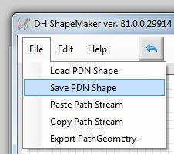

Load/Save PDN Shape
Paint.net 4.0.6+ allows the addition of custom Shapes to the Shapes menu. These Shapes are stored in the Paint.net\Shapes\ directory. The first two entries in the File menu allow for loading one of these Shapes or saving the current Shape in a paint.net compatible (XAML) format in the correct directory.
Note: You will need to restart paint.net to use a newly saved Shape as they are only loaded on start up.

Paste Path Stream
Paste Path Stream is used to copy SVG Shapes into ShapeMaker. Simply copy the SVG code between the Path tags then hit File > Paste Path Stream to paste the Shape into the Drawing grid and Path List.
Paste Path is capable of interpreting StreamGeometry strings which are a lightweight version of
PathGeometry strings. Both can appear in XAML files - but only StreamGeometry can be parsed by ShapeMaker. Users attempting to paste in PathGeometry strings will get a "Bad Format" error even though there is nothing 'wrong' with the string.
For further information can be found on the distinction between the two string formats using these links: Microsoft Stream Geometry Tutorial https://msdn.microsoft.com/en-us/library/ms742199(v=vs.110).aspx Microsoft Geometry Overview https://msdn.microsoft.com/en-us/library/ms751808%28v=vs.110%29.aspx

Copy Path Stream
Copy Path Stream copies all the Paths in the Path List to the clipboard for pasting elsewhere. Use this option to export SVG graphics outside of the paint.net environment.

Export PathGeometry
Saves the Shape to an XAML file using the more complex PathGeometry format. Use this option to save Shapes for reuse outside of the paint.net environment.

Edit Menu
The Edit menu contains editing tools to manipulate the current Line/Curve, Path or Shape. The menu can be opened by clicking on it or using the keyboard combination Alt + E.

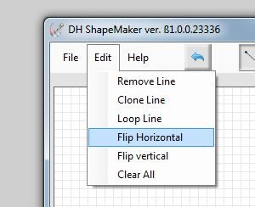
Some of these commands have different effects depending on which mode ShapeMaker is currently in (Path Mode or Line Mode). This table should clarify some of these differences.

Path Mode Line Mode Line Mode

(Empty Buffer) (Edit Line) (New Line)

Remove Line yes yes no

Clone Line | yes | yes | no
Loop Line | no | yes | yes
Flip Horz | yes | yes | yes
Flip Vert yes yes yes

Remove Line (Delete key)
Erases the currently highlighted Path from the Path List.

Clone Line
Creates a duplicate of the currently highlighted Path. The duplicate is drawn on top of the existing Path, move the new Path (Shift + drag any nub) to relocate it.

Loop Line (Ctrl + 1)
Relocates the End point of the highlighted Path to the same location as the Start point of the Path. This is a simple way to close a Shape.
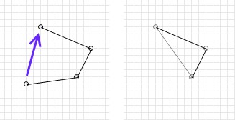

Flip Horizontal
In Line Mode (when a Line/Curve is actively being edited) this command mirrors the entire Line/Curve horizontally.
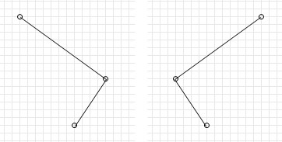
Before Flip Horizontal After Flip Horizontal

In Path Mode (when no Line/Curve is active), Flip Horizontal flips the entire Shape.

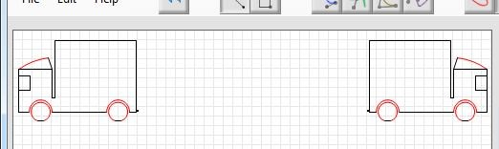
Original Shape Following Flip Horizontal

Flip Vertical
In Line Mode (when a Line/Curve is actively being edited) this command mirrors the entire Line/Curve vertically.
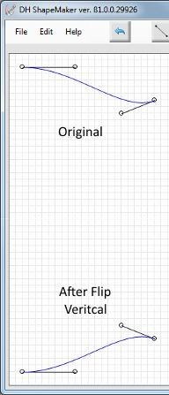

In Path Mode (when no Line/Curve is active), Flip Horizontal flips the entire Shape.
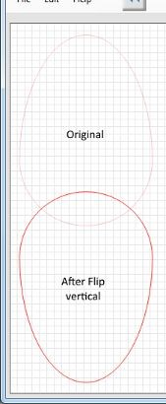

Clear All
Clear All removes all the entries from the Path List. This has the same effect as clearing the entire drawing grid.

Help Menu
The Help menu can be opened by clicking on it or using the keyboard combination Alt + H. The menu contains three entries:

User's Manual
Opens this user manual using the installed PDF viewer. The PDF is bundled with ShapeMaker. The PDF file should be placed in the paint.net/Effects/ folder along with the ShapeMaker dll in order to make it available from within ShapeMaker.

Keyboard Shortcuts
Opens a window showing the available keyboard shortcuts.

About
Shows the following dialog with copyright and authorship details.
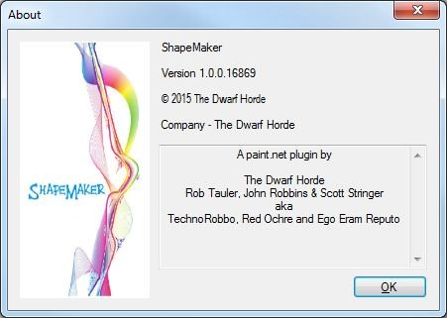

Tool Bar
The Tool Bar contains a number of icons which are used to change drawing tool and provides some options for how the current Line, Curve or Path behaves.
From left to right the icons are
- Undo - reverses the last change in the editing buffer. o Straight Lines - Creates Straight Lines between Start and End points. o Auto Rectangle - Creates a Rectangle between Start and End points.
- Cubic Bézier - Creates a Cubic Bézier Curve between Start and End points.
- Smooth Cubic Bézier - Creates a Smooth Cubic Bézier Curve between Start and End points.
- Quadratic Bézier - Creates a Quadratic Bézier Curve between Start and End points.
- Smooth Quadratic Bézier - Creates a Smooth Quadratic Bézier Curve between Start and End points.
- Elliptical Arc - Creates an elliptical arc between Start and End points. o Large Arc (over 180 degrees) - Toggles which portion of an Elliptical Arc is drawn.
- Sweep Direction - Toggles between clockwise and anti-clockwise directions for the Elliptical Arc.
- Auto Circle - Creates a Circle whose diameter is set by Start and End points. o Snap to Grid - Forces control nubs and points onto grid boundaries.
- Linked with previous Line - Keeps the last created End point active following Apply Edit so another Line/Curve can be drawn from the same point.
- Closed Path - Automatically closes a Path by drawing a Straight Line from End point back to the Start point.

Undo  (Ctrl + Z)
The Undo button rolls back the last change. This might be the creation of, or modification to, a Line or
Path.
Undo is a single ply tool. It will undo the very last change only.

Snap to Grid 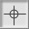 (Ctrl + S)
This toggle forces new points and points being dragged onto Drawing Grid boundaries.
If Snap-To-Grid is enabled, a new point will be created on the nearest grid boundary. If Snap-To-Grid is disabled the point will be created where the mouse cursor is located. Similarly when dragging a point, grid boundaries will be forced if Snap-to-Grid is enabled.
Existing points are not relocated by this button.

Linked Lines  (Ctrl + 3)
This toggle button when enabled preserves the focus on the last created End point when the Apply Edit button is clicked. This feature allows the next Line/Curve to be drawn from the same point.
If this feature is disabled, clicking Apply Edit removes the focus from the entire previous object.

Closed Path 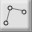 (Ctrl + 2)
When the Closed Path feature is engaged, any Shape being drawn will automatically be closed with a straight Line from the current End point back to the Start point.
Enable Closed Path if you wish to create a closed Shape automatically. Disengage the Closed Path feature to leave a Shape open.
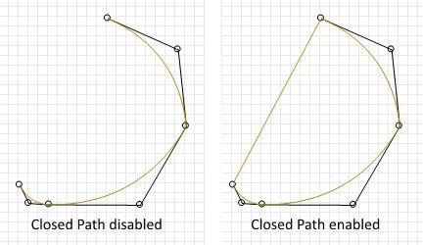

Drawing Grid
The Drawing Grid is where Lines and Curves are drawn to create Paths and Shapes.
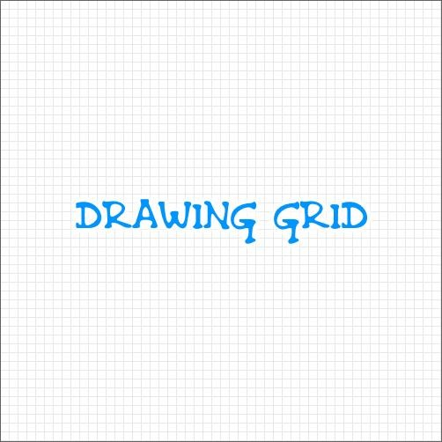

The Drawing Grid is set a default grid size, so the grid dimensions cannot be altered. If you want to zoom in on the Grid, check the 2x View checkbox. This will double the view size.
When 2x View is checked, the Alt key + left mouse button allows the Shape and background to be panned around the drawing grid.

If Snap-To-Grid is enabled, new points and points being dragged around the Drawing Grid will be forced onto Grid boundaries. This is useful for creating straight Lines and aligning points.
If Snap-To-Grid is disabled new points will be created where the mouse cursor is located. When dragging a point the Grid is ignored.

The currently active paint.net layer is shown behind the Drawing Grid. Alter the opacity of the layer by changing the See Background slider. This feature allows the layer to be used as a base for tracing.
If the Fit Background checkbox is checked, the background layer is scaled to fit within the Drawing Grid. The height and width ratio is maintained when scaling.
If Fit Background is unchecked, the unscaled layer is either centered in the drawing grid space (if less than 500px square) or aligned to the top left corner (if greater than 500px square).

Note that the Drawing Grid is not rendered to the paint.net layer or output with any file saved by ShapeMaker. It's purpose is simply to aid the actual creation of Shapes.

Path List, Editing Tools & Options
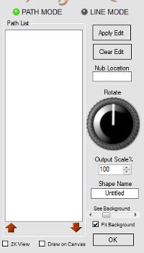
A note about Path Mode and Line Mode:
In ShapeMaker there are two modes or methods of operation; Line Mode and Path Mode. For the most part there are seamless transitions into and out of each mode while a Shape is being created.

Line Mode
Line Mode refers to a selected Line/Curve being actively edited or a new Line being drawn. In other words the Line/Curve is active and the control nubs and Start/End points are visible. Technically, Line Mode describes something being placed in the editing buffer.
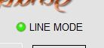
In Line Mode, editing operations are confined to the active Line/Curve or Path.
To enter Line Mode, click any entry in the Path List or create a new point (right click on the drawing grid).

Path Mode
Path Mode refers to all Paths listed in the Path List and all the components of those Paths. Path Mode is active when no Lines are being edited and no control nubs or points are visible.
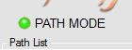
In Path Mode editing operations affect all the Paths. Flip or Rotate for example will be applied to the entire Shape.
To quickly enter Path Mode, click the Apply Edit button (or Enter Key) followed by the Deselect button (or Esc Key). This saves any changes to the currently active Path and deselects it. Path Mode is automatically engaged.
The following table demonstrates how the editing tools change function for the different editing modes.

 | Path Mode (Empty Buffer) | Line Mode  (Edit Line) | Line Mode  (New Line)
Remove Line | yes | yes | no
Clone Line | yes | yes | no
Loop Line | no | yes | yes
Flip Horz yes yes yes

Flip Vert yes yes yes

Path List
The Path List contains a list of all the Paths that have been committed to the Shape.
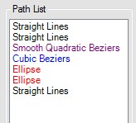
The Path List operates much like paint.net's Layers Window. Paths can be reordered, cloned, flipped, removed looped and re-edited.
To focus the editing operations on a specific Path (i.e. engage Line Mode) - click on the Path in the Path List. The selected Path will become editable on the drawing grid with all associated Control Nubs activated (the Path will be placed in the editing buffer).
If you do make changes to an existing Path remember to commit the changes by clicking the Apply Edit button (or use the Enter Key).

Up/Down Arrows
ShapeMaker supports reordering of the entries in the Path List. The correct order of Paths is necessary to close a Shape when using an automated SVG fill to color the Shape.
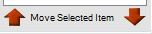
Highlight a Path in the Path List and click the arrows to shift the Path higher or lower in the list.

Apply Edit (Enter Key)
This button commits changes made to the currently active object.
If a new object is being created a Path will automatically be created in the Path List for the object.
If an existing Path is being edited (i.e. one that already exists in the Path List) the Path will be updated by clicking the Apply Edit button.
Deselect (Esc Key)
This button removes the editing focus from the last object's End point and engages Path Mode. In other words it deselects the currently active Path or object.

Nub Location
The location of the last created or moved nub or point is shown in the Nub Location box.
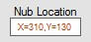
The X coordinate is the horizontal dimension from the left hand side of the drawing grid. The Y coordinate is the distance from the top of the drawing grid.

Rotate Knob
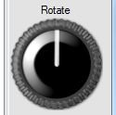
While an object is being actively edited (i.e. Line Mode is engaged), the Rotate knob will rotate the object on the drawing grid.
Using the Rotate knob in Path Mode will rotate the entire image.

Output Scale
This control determines the size of the Shape in relation to what is visible on the drawing grid.
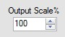
100% represents a 1:1 ratio in pixel terms. Lower values will reduce the output size while larger values will increase the output size.

Shape Name
This text box is used to name your Shape.
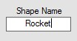
In paint.net this name will be used as a tool tip when the Shape is hovered over in the Custom Shapes menu.
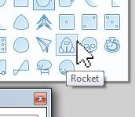
If a Name has been specified in the Name box it will be used to prepopulate the File Save dialog when saving the Shape to file.

Image Tracing Opacity
This slider determines the opacity of the active paint.net layer which is shown behind the drawing grid. This feature allows the layer to be used as a base for tracing.
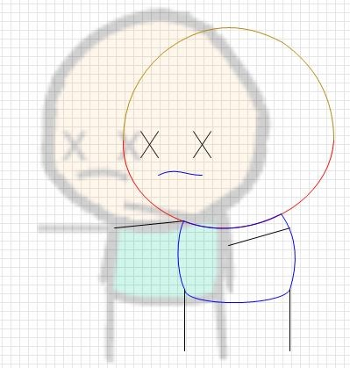

Fit Background
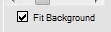
If the Fit Background checkbox is checked, the background layer is scaled to fit within the grid space. The height and width ratio is maintained.
If unchecked, the unscaled layer is either centered in the drawing grid space (if less than 500px square) or aligned to the top left corner (if greater than 500px square).

2x View
This checkbox doubles the view size of the Drawing Grid. Check it to zoom in to fine tune Shapes and nub positions.
When Zoom2X is checked, the Alt key + left mouse button allows the Shape and background to be panned around the drawing grid.

Draw on Canvas
The Draw on Canvas checkbox renders the current Shape to the currently active paint.net layer.
The Lines and Curves in the Shape will be rendered in the Primary color. Line with will be dictated by the current Brush Width setting. Any closed areas in the Shape will be filled with the Secondary color.
Remember that only Paths that appear in the Path List form the Shape. If you have made changes you need to click Apply Edit to commit the changes to the Path List.
Note: Draw on Canvas uses the Scale Ratio value to scale the output size.

Drawing Types
There are four Primitive types, two Smooth types and two Compound types.
Primitive Types - Straight Line, Cubic Bézier, Quadratic Bézier and Ellipse.
Smooth Types - Smooth Cubic Bézier and Smooth Quadratic Bézier.
Compound Types - Rectangle and Circle.
These are the basic building blocks from which Shapes are formed. If the same type is linked in a series the resultant "string" is called a Path.
Think of the relationship Line/Curves > Paths > Shapes like the relationship words > sentences > paragraphs. In ShapeMaker, the contents of a Path (sentence) must contain Lines or Curves (words) of the same type. You can add as many Paths (sentences) as you need to create a Shape (paragraph).

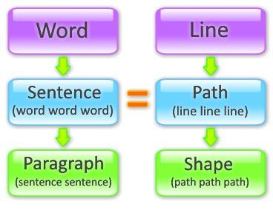

The Primitive Types
Straight Line 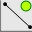 (Ctrl + L)
The Straight Line draws a continuous Line between the Start point and End point (the black Line shown in the following diagram).
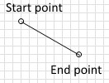
To draw a Straight Line, select the Straight Line type. Right click anywhere there is a clear space on the drawing grid. This will place the Line Start point. Right click in another clear space to set the Line End point. The Line will be drawn between the two points.
Drag either of the points with the left mouse button to adjust the length and angle of the Line.
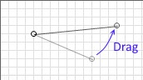
To draw a connected series or Path of Straight Lines, add more points by right clicking. The new Lines will be added in a continuous sequence or series. Each new Line will be connected to the previous Line's End point.
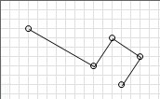

Cubic Bézier 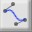 (Ctrl + B)
The Cubic Bézier draws a continuous smooth Curve between the Start point and End point (the blue colored curve shown in the following diagram).
Two Control points are used to independently adjust the amount of curvature and the magnitude at opposite ends of the Curve.
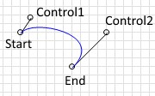
The Start and End points can be moved as described above (i.e. drag with left mouse button - see Straight Line). Similarly, either Control point can be dragged with the left mouse to relocate it.
The Control Points are connected to their parent point via a line segment. The rotation or angle that the line segment makes adjusts the curvature.
Drag the Control point further away from the parent point to increase the magnitude of the curvature. Dragging the Control point closer decreases the magnitude of the curvature.
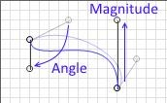
To draw a connected series or Path of Cubic Béziers, add more points by right clicking. The new Curves will be added in a continuous sequence or series. Each new Curve will be connected to the previous Curve's End point.
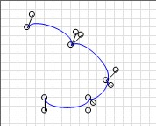

Quadratic Bézier 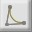 (Ctrl + Q)
The Quadratic Bézier draws a continuous smooth curve between the Start point and End point (the tan colored curve shown in the following diagram).
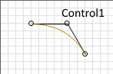
The Curve is governed by a single Control point. The Control point is used to simultaneously adjust both the amount of curvature and the magnitude. Two line segments give visual cues to the angle and magnitude of the Curve.
The Start and End points can be moved (drag with left mouse button - see Straight Line). Drag the Control point with the left mouse to similarly relocate it.
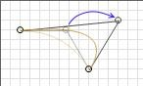
To draw a connected series or Path of Quadratic Béziers, add more points by right clicking. The new Curves will be added in a continuous sequence or series. Each new Curve will be connected to the previous Curve's End point.
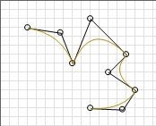

Ellipse 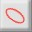 (Ctrl + E)
(Dwarf Horde would like to acknowledge and give credit to svg.codeplex.com for the Elliptical Arc Algorithm)
The Ellipse type draws an elliptical curve from the Start point to the End point (the red curve shown in the following diagram).
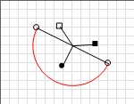
The Elliptical Curve is governed by three Control points; one each for Rotation, Y-radius and X-radius.
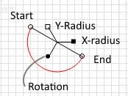

As with all other Control points, Left -click and hold to drag the point to a new location. The length of the line segment gives a visual clue to the magnitude while the angle of the rotation line segment determines the angle.
Note: If the X-Radius and Y-Radius Control points are of the same magnitude (i.e. superimposed on each other) the Curve will be circular.
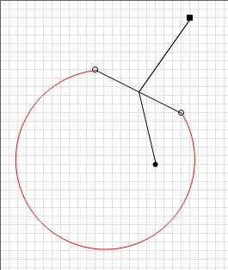

The Large Arc button 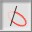 is used to 'flip' the region of a Curve that is drawn. In the following diagram, two ellipses have been drawn with the same parameters. The only difference is the state of the Large Arc button.
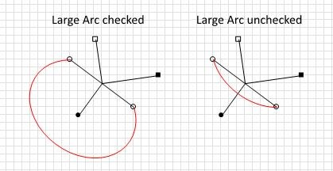
We can see that the two curves would form a whole ellipse if one were rotated by 180 degrees and superimposed.
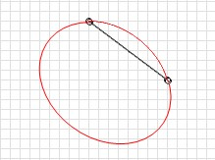

The Sweep Direction button 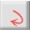 determines which direction the Ellipse is drawn in; clockwise or anticlockwise. Toggling this checkbox inverts the Ellipse across the line between the Start point and the End point.
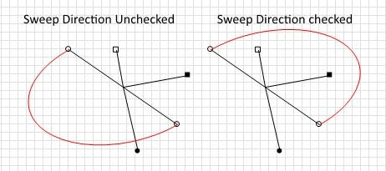

The Smooth Types
Smooth Cubic Bézier 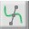 (Ctrl + Shift + Q)
Naturally this is a similar curve to the Cubic Bézier. The difference is how joined Curves are linked by common Control devices which ensure that the Curve is...
- Is continuously smooth from one end to the other, and
- Extends through the center of all Start, Mid and End points.
A single instance of a Smooth Cubic Bézier looks like the following diagram. Note the single Control point.
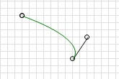

When a second Smooth Cubic Bézier is chained to the first to create a Path, the common point shares a pair of Control points which are linked together. The two Control points pivot about the common point much like a binary star or a seesaw.
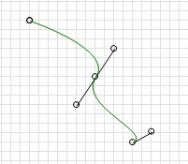

These twin Control points affect the Curve either side of the common point. Length of the line segments determines magnitude of the Curve while the rotation affects the curvature.
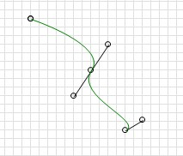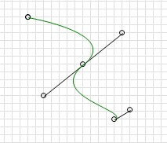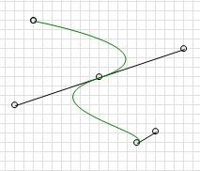

Smooth Quadratic Bézier 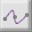 (Ctrl + Shift + Q)
Naturally this is a mathematically similar curve to the Quadratic Bézier. However it appears quite different. The difference is how joined Curves are linked. Gone are the Control points. Instead, the
Curve is changed by dragging the Curve's common points. Like the Smooth Cubic Bézier, this Curve is...
- Is continuously smooth from one end to the other, and
- Extends through the center of all Start, Mid and End points.
A single instance of a Smooth Quadratic Bézier looks like a Line. See the following diagram. Note the complete lack of Control points.
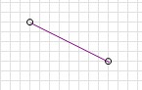

When a second Smooth Quadratic Bézier is chained to the first to make a Path, the common point becomes a Control point.
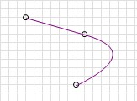
The Common points affect the curvature either side of the point. In the next four diagrams, only the central Control point has been moved. The Start and End points remain the same throughout.
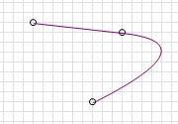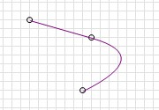

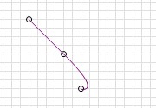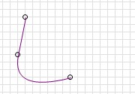

The Compound Types
Rectangle 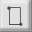 (Ctrl + R)
This is a macro type tool which simplifies the creation of rectangles. This combination type draws a Rectangle between Start and End points.
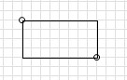
Internally the Rectangle is converted to four ordinary Straight Lines. It's much easier to draw this way!
If multiple Rectangles are chained together (a Path), each new Rectangle will use the previous one's End point as its Start point.
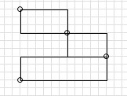
If a common point is relocated by dragging, both Rectangles will have their size affected.
Rectangles in a Path may be overlapped. In the following diagram, the third Rectangle (colored yellow for clarity) overlaps the first Rectangle in this Path consisting of three Rectangles.
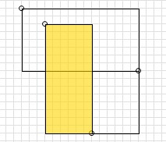

Circle 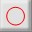 (Ctrl + I)
This is a macro type tool which simplifies the creation of circles.
The tool draws two semi circles from Start point to End point - but in opposite directions. The result is a full Circle with the diameter equal to the distance between Start and End points.
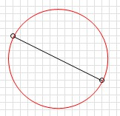
Internally the Circle is converted to two semi-circular elliptic arcs with an opposite Sweep Direction. Once a Circle is committed to the Path List it is shown as two Ellipse entries. The Circle ceases to be a single unit when it comes to re-editing.
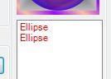
Multiple Circles cannot be chained together to form a Path. Each Circle forms a pair of Elliptical Paths.
If the Start or End point is moved, the size of the Circle is changed. Drag the points further apart to make the Circle larger. Drag the points closer together to make the Circle smaller. Dragging one point clockwise or anti-clockwise about the other rotates the Circle about the stationary point.
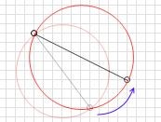

Creating Points
Right click any clear space in the drawing grid to create a new Start or End point.
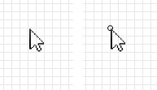
If Snap-To-Grid is enabled, the point will be created on the nearest grid boundary. If Snap-To-Grid is disabled the point will be created where the mouse cursor is located.

Creating Primitives, Smooth Types or Compound Types
Right click any clear space in the drawing grid to create a new Start point. Right click on another location to place the End point. The currently selected Primitive/Smooth/Compound type will be drawn between the two.
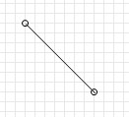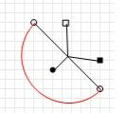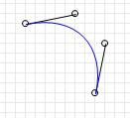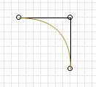

Straight Line Ellipse Cubic Bézier Quadratic Bézier
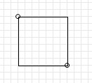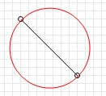

Rectangle Circle
If the Type has associated Control points these can be moved just as any other point while the current object remains active (the Control nubs are visible).

Tip! Hold the Ctrl key down while dragging a point or nub to hide the control nubs, control lines and points. This makes viewing the Curve easier. Release the Ctrl key to show these guides again.
Smooth types can be drawn as individual elements, however they are intended to be used in series.
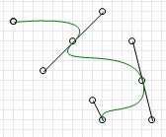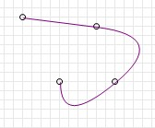
Three Smooth Cubic Béziers Three Smooth Quadratic Béziers

Moving Points and Objects
Line Mode (when a Line/Curve is active):
Drag any visible point with the left mouse button to adjust its position.
If Snap-To-Grid is enabled, the point will be relocated only to grid boundaries. If Snap-To-Grid is disabled the point can be located anywhere in the drawing area.
Hold Shift while dragging any nub in the currently active object to move the entire object.
Hold the Ctrl key down while dragging a point or nub to hide the control nubs, control lines and points. This makes viewing the Curve easier. Release the Ctrl key to show these guides again.
While an object is being actively edited (Line Mode), the Rotate knob will rotate the object.
To commit an edited object to the Path List, press Apply Edit.
By default the last point in the previous object is used as the start point for any subsequent objects.
This links them together via a common point. If this behavior is not desired, deselect the Linked Lines  option. When Apply Edit is clicked the last point will not be shown.
If a separate object is desired, click Clear Edit. This allows the next created point to be located anywhere. Clicking Clear Edit also engages Path Mode.

Path Mode (when no Line/Curve is active):
Holding Shift while dragging moves the entire image.
Using the Rotate knob will rotate the entire image.
In Path Mode (i.e. when no Line is active) clicking near an end point or crease on a Line in the image will select the associated Path. The Path will be selected (i.e. made active with the Controls showing) and Line (edit) mode will be automatically engaged.

Quick Start Guide
Open the plugin from Effects > Advanced > DHShapeMaker
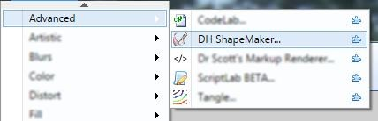

Select the option to Snap by ticking the checkbox. This forces all points (Start, End and Control nubs) onto the grid intersections.
Select the type of Line or Curve you wish to draw.
What does Closed do? It automatically closes a Path by drawing a straight Line from the End point back to the Start point. Check this if you wish to create a closed Shape.
Right click anywhere on the grid to place the Line/Curve Start point.
Click anywhere else on the grid to locate the End point of the Line/Curve.
Drag a Start/End point by clicking + holding the left mouse button while you drag the mouse around. The point will follow the mouse and the Line will be redrawn between the Start and End points. Release the mouse button to stop dragging the point.
If the type you're drawing with is a Curve, control points will be shown. These alter the curvature by changing the angle of the Curve and magnitude. Change the angle of the Curve by dragging the control point clockwise or anticlockwise. Change the magnitude of the Curve by dragging the control point further away from it's reference point(s). Cubic Béziers have two control points associated with the Start and End points. Quadratic Béziers have a single control point
Create another Line/Curve by clicking a new location on the grid. The new Line/Curve will automatically be joined to the End point of the first Line. Add as many new Line/Curve as you like.
Hold down the Shift key and drag any point in the series. The entire Path of Lines moves with the mouse.
The series of Lines is still being actively edited. To commit the Path (or any changes) to the Path List, click on the Apply Edit button. Once clicked the Path is entered into the Path List and editing ceases.
Add another Path using a different type of Curve or Line. See how this second Path automatically joined the terminus of the first Path? What if you don't want that? Click Clear Edit to disengage the automatic connection of a new Path to a previous one.
Commit the second Path to the Path List by clicking Apply Edit.

Quick Reference - Primitive Types
 | Primitive |  | Path (Series) |  | Closed Form
Straight Line |  | 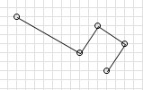 |  | 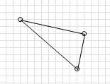
Ellipse |  | No Series.  Individual Ellipses form their own complete Path. |  | 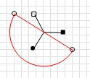
Cubic Bézier |  | 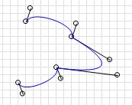 |  | 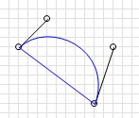
Quadratic  Bézier | 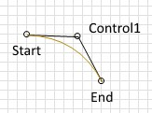 | 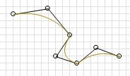 |  | 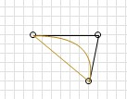

Quick Reference - Smooth Types
 | Smooth Type |  | Path (Series) |  | Closed Form
Smooth Cubic  Bézier | 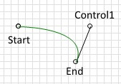 | 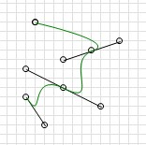 |  | 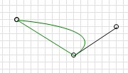
Smooth Quadratic  Bézier | 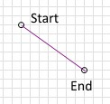 | 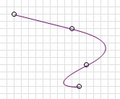 |  | 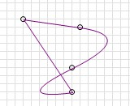

Quick Reference - Compound Types
 | Compound Type | Path (Series) | Closed Form
Straight Line +  Rectangle | 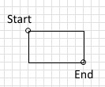 | 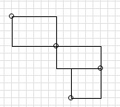 | 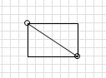
Ellipse + Circle | 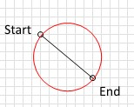 | No Series.  Individual Circles form their own complete Path. | 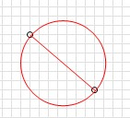

Quick Reference - Mouse & Keyboard Shortcuts
Mouse
Right Click on Work Area to add a nub
Right Click on a nub to delete that nub (note: you cannot delete the first nub in a Path)

Left Click + Hold a nub or handle to drag it to a new location
Left Click in Path Mode on the end or corner of any Line or Curve to select it.
Left Click + Shift Key in Line Mode - click and drag a nub to move entire Line.
Left Click + Shift Key in Path Mode - click and drag on clear space to move entire Path.
Left Click + Alt Key in 2X View pans the entire work area.
Left Click + Ctrl hides the control nubs and points to better view a Line or Curve.

Keyboard
Ctrl + L | Line
Ctrl + R | Rectangle
Ctrl + I | Circle
Ctrl + B | Cubic Bézier
Ctrl + Shift + B Smooth Cubic Bézier
Ctrl + Q Quadratic Bézier
Ctrl + Shift + Q Smooth Quadratic Bézier
Ctrl + E | Ellipse
Ctrl + S | Snap to Grid
Ctrl + 1 | Loop Line
Ctrl + 2 | Close Path
Ctrl + 3 | Link Lines
Enter | Apply Edit
Esc | Clear Edit

